The .NET Framework is a framework for developing and implementing software for personal computer, web etc.

* .NET has a rich collection of class library (called the Base Class Library) to implement GUI, query, database, web services etc.
* Programs developed with .NET needs a virtual machine to run on a host. This virtual machine is called Common Language Runtime (CLR).
* Since the compiler doesn’t produce native machine code, and its product is interpreted by the CLR, there’s much security.
* .NET allows using types defined by one .NET language to be used by another under the Common Language Infrastructure (CLI) specification, for the conforming languages.
* Any language that conforms to the Common Language Infrastructure (CLI) specification of the .NET, can run in the .NET run-time. Followings are some .NET languages.
* Visual Basic
* C#
* C++ (CLI version)
* J# (CLI version of Java)
* A# (CLI version of ADA)
* L# (CLI version of LISP)
* IronRuby (CLI version of RUBY)
* Microsoft provides a comprehensive Integrated Development Environment (IDE) for the development and testing of software with .NET. Some IDEs are as follows
* Visual Studio
* Visual Web Developer
* Visual Basic
* Visual C#
* Visual Basic

**Components of Dot Net framework:**

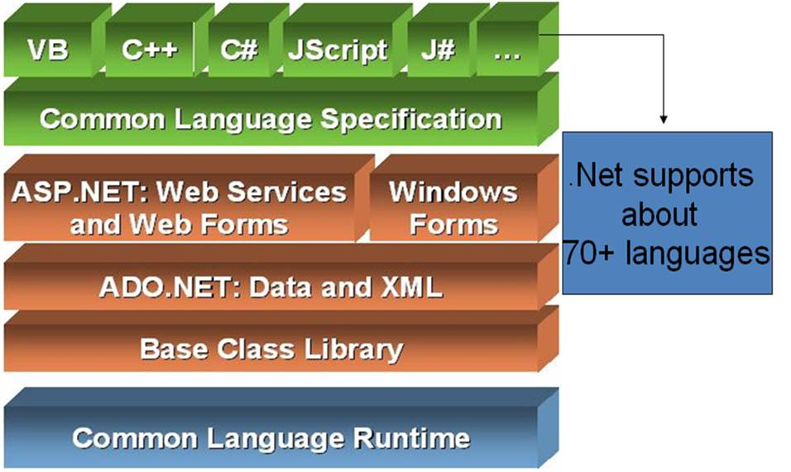

Net Framework is a platform that provides tools and technologies to develop Windows, Web and Enterprise applications. It mainly contains two components,

1.   Common Language Runtime (CLR)

2.    .Net Framework Class Library.

1**. *Common Language Runtime****(CLR)*.Net Framework provides runtime environment called **Common Language Runtime (CLR)**.It provides an environment to run all the .Net Programs. The code which runs under the CLR is called as **Managed Code**. Programmers need not to worry on managing the memory if the programs are running under the CLR as it provides memory management and thread management.  
  
Programmatically, when our program needs memory, CLR allocates the memory for scope and de-allocates the memory if the scope is completed.  
  
Language Compilers (e.g. C#, VB.Net, J#) will convert the Code/Program to Microsoft Intermediate Language (MSIL) intern this will be converted to Native Code by CLR. See the below Fig.

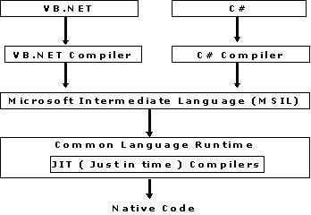

There are currently over 15 language compilers being built by Microsoft and other companies also producing the code that will execute under CLR.   
  
2.    ***.Net Framework Class Library (FCL)***  
  
This is also called as Base Class Library and it is common for all types of applications i.e. the way you access the Library Classes and Methods in VB.NET will be the same in C#, and it is common for all other languages in .NET.   
  
The following are different types of applications that can make use of .net class library.

1.                   Windows Application.

2.                   Console Application

3.                   Web Application.

4.                   XML Web Services.

5.                   Windows Services.

In short, developers just need to import the BCL in their language code and use its predefined methods and properties to implement common and complex functions like reading and writing to file, graphic rendering, database interaction, and XML document manipulation.  
  
Below are the few more concepts that we need to know and understand as part of this .Net framework.    
  
3.   ***Common Type System****(CTS)*   
  
It describes set of data types that can be used in different .Net languages in common. (i.e), CTS ensures that objects written in different .Net languages can interact with each other.  
  
For Communicating between programs written in any .NET complaint language, the types have to be compatible on the basic level.  
  
The common type system supports two general categories of types:    
 ***Value types:***  
  
Value types directly contain their data, and instances of value types are either allocated on the stack or allocated inline in a structure. Value types can be built-in (implemented by the runtime), user-defined, or enumerations. ***Reference types:***  
  
Reference types store a reference to the value's memory address, and are allocated on the heap. Reference types can be self-describing types, pointer types, or interface types. The type of a reference type can be determined from values of self-describing types. Self-describing types are further split into arrays and class types. The class types are user-defined classes, boxed value types, and delegates.    
  
4**. *Common Language Specification (CLS)***  
  
It is a sub set of CTS and it specifies a set of rules that needs to be adhered or satisfied by all language compilers targeting CLR. It helps in cross language inheritance and cross language debugging. ***Common language specification Rules:***  
  
It describes the minimal and complete set of features to produce code that can be hosted by CLR. It ensures that products of compilers will work properly in .NET environment.

***Sample Rules:***

1.       Representation of text strings

2.       Internal representation of enumerations

3.       Definition of static members and this is a subset of the CTS which all .NET languages are expected to support.

4.   Microsoft has defined CLS which are nothing but guidelines that language to follow so that it can communicate with other .NET languages in a seamless manner.